Step 1: Setup Your Discord Bot and Establish a Relationship
(without this, the bot will never be able to message you)
Expected Time: 5-7 minutes

- Log into https://discord.com/developers/applications
- Select “New Application” (top right corner, blue box)
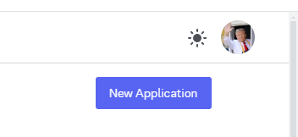
- Give it a name, e.g. “StashSage”
- Go to “Bot” tab on the left menu, under Privileged Gateway Intents, enable the 3rd option: “Message Content Intent”
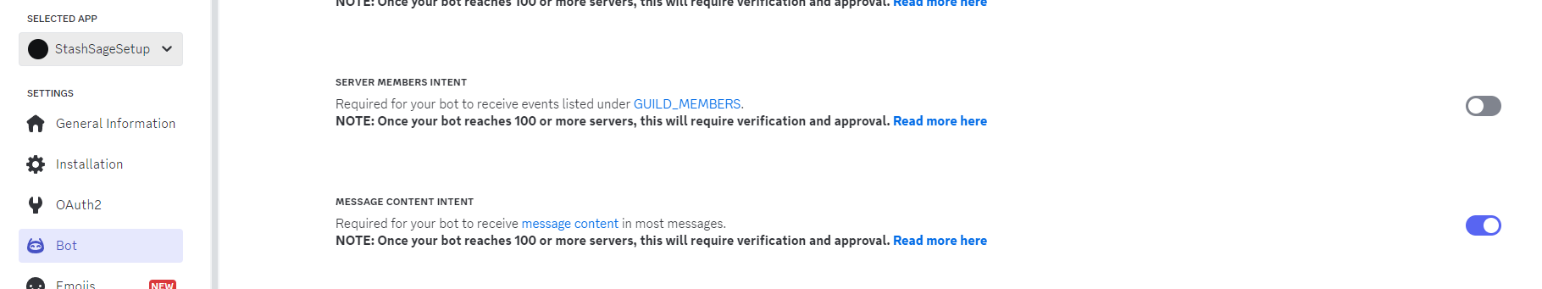
- Go to Discord, on the left bar with your list of servers, click the “+” button to create a new private server (Create My Own > For Me & Friends). Don’t worry, you can delete it after this.
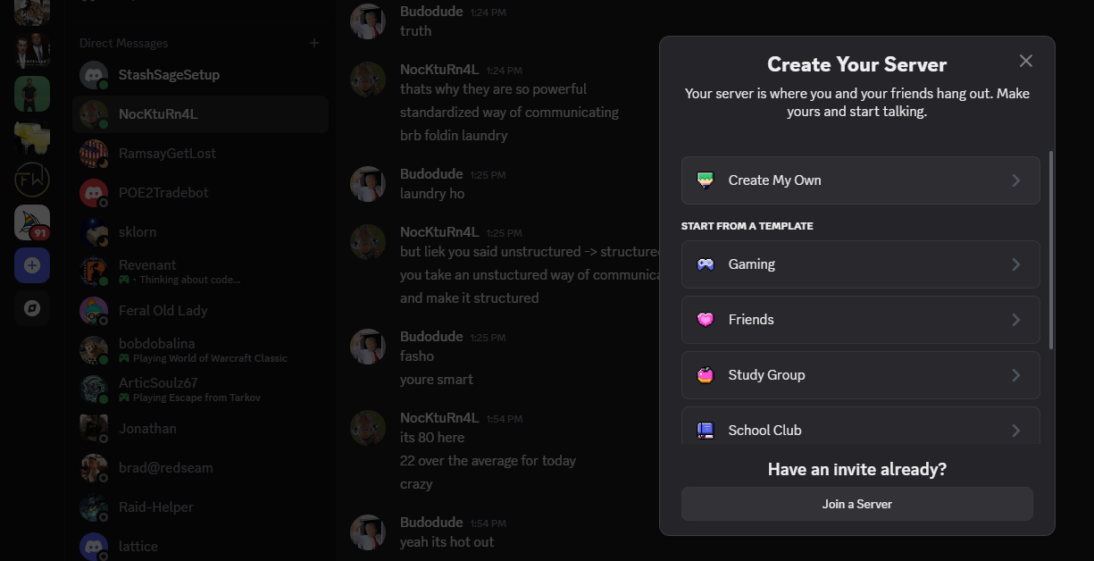
- Enter the following link into your browser, replacing the “YOUR_BOT_APPLICATION_ID” with your bot’s Application ID, which can be copied from the “General Information” tab in the Discord Developer menu.
https://discord.com/oauth2/authorize?client_id=YOUR_BOT_APPLICATION_ID&scope=bot&permissions=8
For example:
https://discord.com/oauth2/authorize?client_id=1353378058813132921&scope=bot&permissions=8
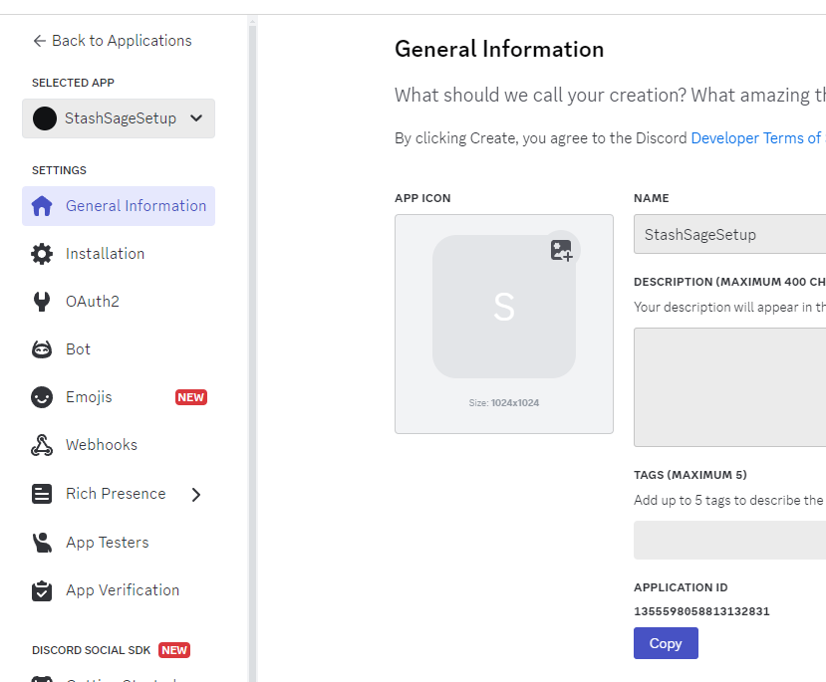
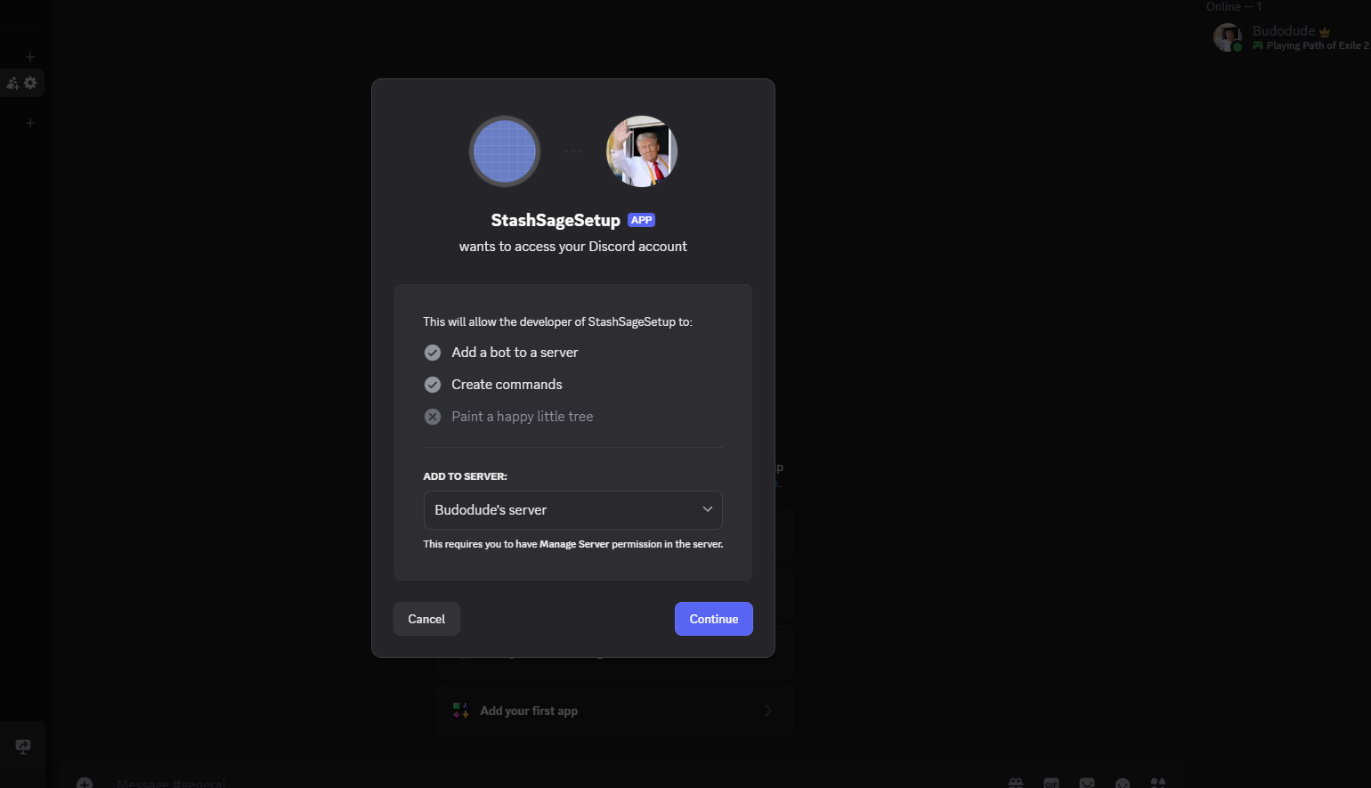

- You should be redirected back to your Discord app and see popup. Invite the Bot to your server. Right click the bot, “Message” it something like “hi”, and you’re done! You have established a relationship with your bot. It can now send you messages. You can also now delete the server.

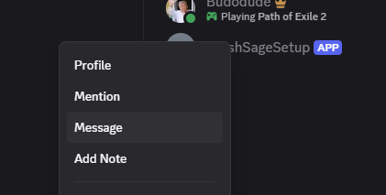
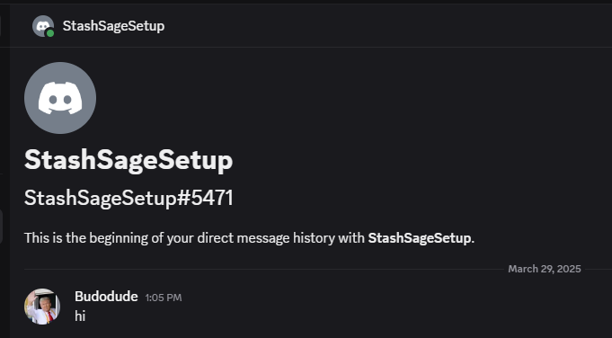

Enter your User ID And Bot’s Token into StashSage Menu
Expected Time: 3-5 minutes
When you first load the StashSage application, you will need to enter your Discord User ID and your Discord Bot Token into the menu, and then select “Save Config & Restart”. You only need to do this once, as the application will save your credentials for future logins. Don’t worry, this information is never shared or transmitted anywhere, only saved within a config.txt file on your computer.
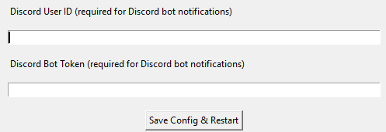
- Go back to https://discord.com/developers/applications
- Select your bot application (e.g. “StashSage”) in the left tab dropdown.
- Go to “Bot” menu, and either Reset Token (if unable to Copy) or Copy Token.
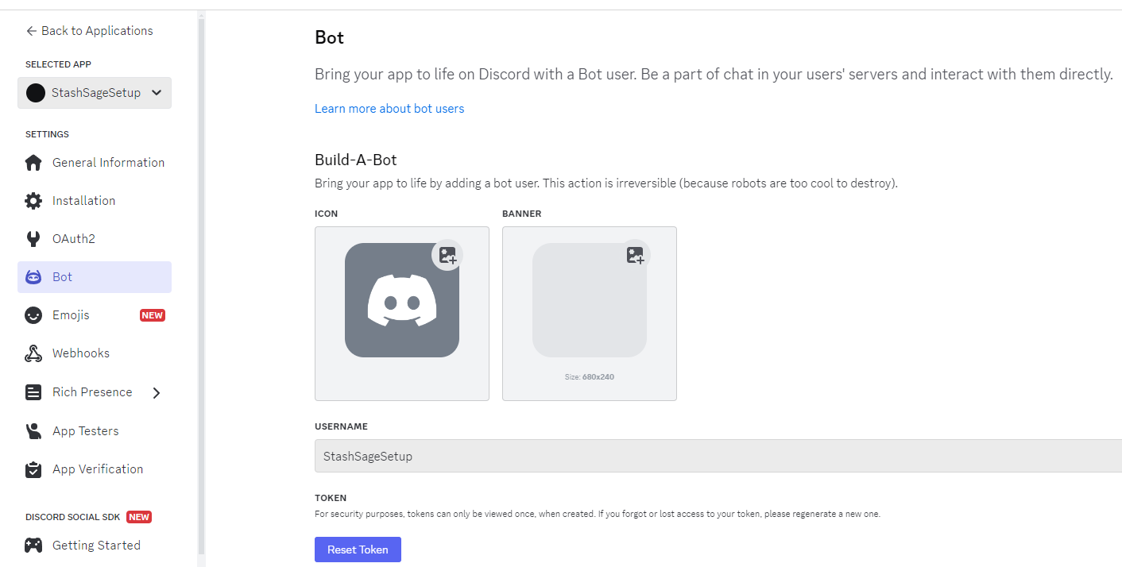
- Paste into “Discord Bot Token” in the UI.
- Finally, go into Discord, access your User Settings with the gear icon in the bottom left near your avatar.
- On the left menu, find “Advanced” near the bottom, and then enable Developer Mode.

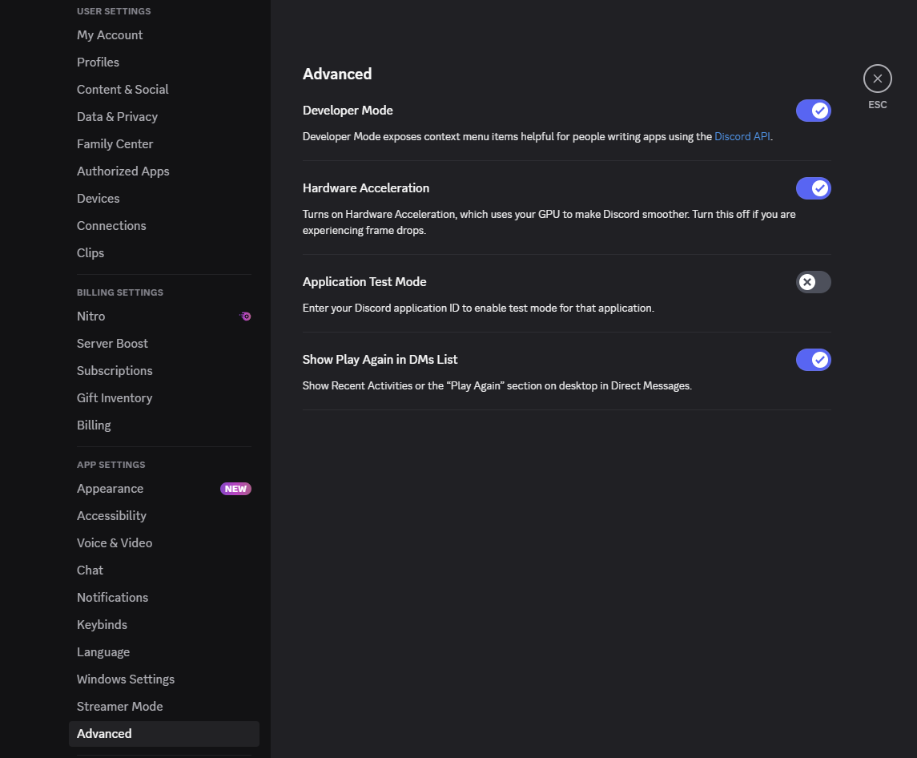
- Exit, click on your name, and “Copy User ID”. Paste this into the “Discord User ID”.
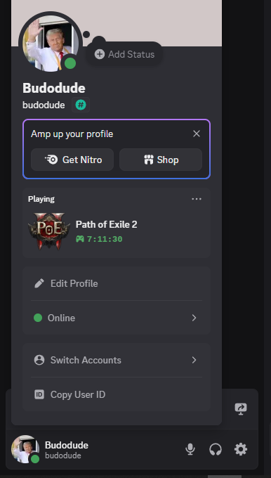
- Click “Save Config & Restart”.

Congratulations! You’ve successfully setup your personal Discord bot and enabled the StashSage application to host your bot and send you messages about your stash trades!

